**School of Engineering**

Grand Valley State University

EGR 326 Embedded System Design

Printed Circuit Board Layout Using Altium Designer

(based on tutorial design for EGR315)

### Objectives

* To explore the PCB layout tools available in the Altium Designer software

### Equipment and Components

### Computer with access to the blade server. The full software can be accessed from the EGR blade server within the EE_CE desktop.

### Introduction

Once the boards are laid out, milling machines or chemical processes are used to convert the design files into physical boards that can be populated with electrical components.

### Altium training videos:

1. Read through the entire laboratory procedure.
2. Watch the video titled “How to Start a Project in Altium Designer” (8:17).
   1. <https://youtu.be/GY2XUxGwqDg>
3. Watch the video titled “Schematic Capture in Altium Designer” (11:00).
   1. <https://youtu.be/YOj7-UgiCL8>
4. Watch the video titled “Compile Design” (5:32).
   1. <https://youtu.be/z2LF0dPixqs>
5. Watch the video titled “Transfer 2 PCB” (4:30).
   1. <https://youtu.be/AQ5ZLyppYI4>
6. Watch the video titled “PCB Rules” (5:30).
   1. <https://youtu.be/GG0RCPMa0gk>
7. Watch the video titled “Placing Components on the PCB” (7:55).
   1. <https://youtu.be/_sUUmZw_yTg>
8. Watch the video titled “Routing the PCB” (8:07).
   1. <https://youtu.be/V3Cs6mai4Ts>
9. Watch the video titled “Checking the PCB DRCs” (4:38).
   1. <https://youtu.be/tuBFzn2o_-4>
10. Watch the video titled “Generating Fabrication Files” (3:23).
    1. <https://www.youtube.com/watch?v=Xn8cFqR1fMU>

### Part I - Schematic Layout EXAMPLE ONLY – for your reference

### In this part, we will use the Altium Designer software to design an electrical schematic and a printed circuit board (PCB). Altium is a professional level PCB designer software used by many engineers around the world. The circuit that we will be designing is called an astable multivibrator (oscillator). Follow the link below if you want to learn more about how this circuit works. This website provides an interactive diagram of this circuit.

### <http://www.falstad.com/circuit/e-multivib-a.html>

### Before we start designing our circuit, make sure you have watched the prelab videos.

1. Log onto the blade server and select the EGR-EE-CE image from the Work Resources screen.

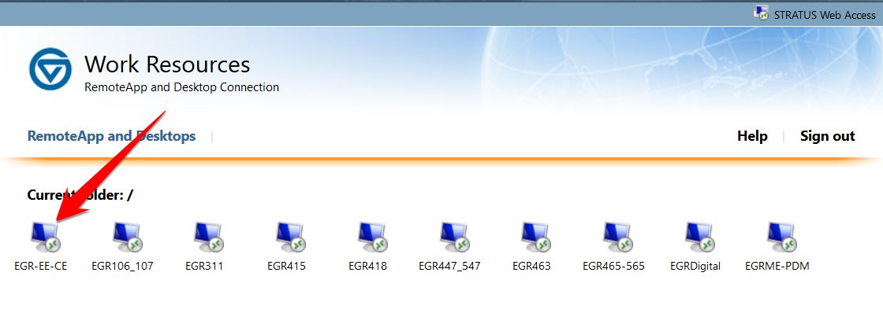

**Figure 1: Blade Work Resources screen**

1. Once you reach the EGR-EE-CE desktop, open Altium Designer.

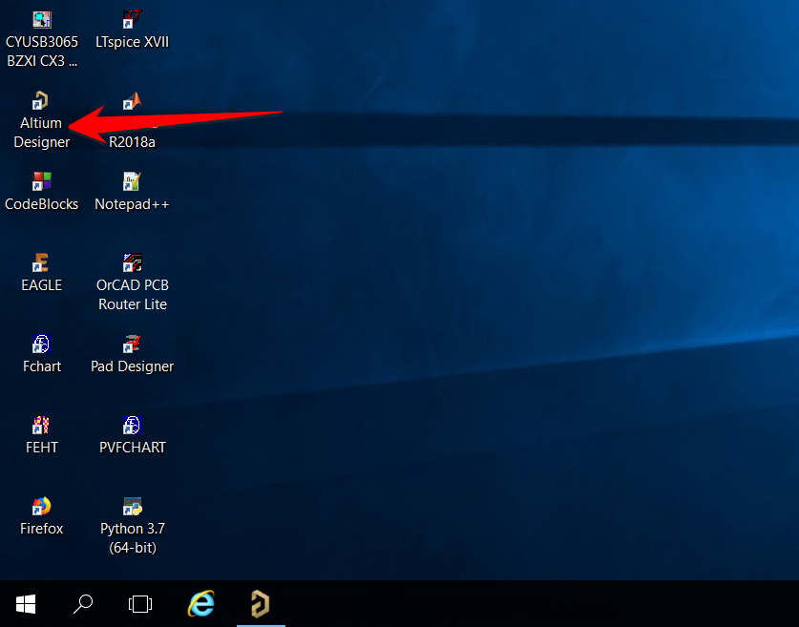

**Figure 2: EGR-EE-CE desktop**

1. Once Altium loads, select **File > New > Project** from the Altium Designer navigation menu.

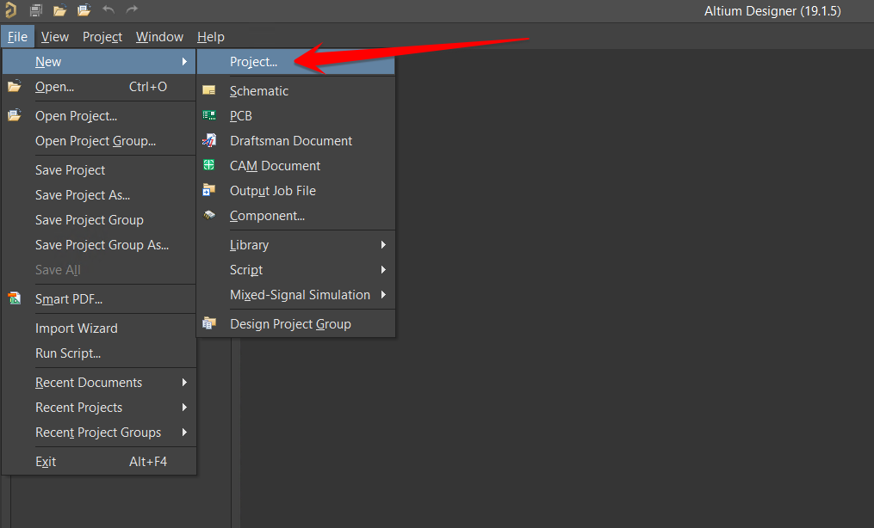

**Figure 3: Creating a new project**

1. At the Create Project screen, leave the project type (1) at default and rename the project name (2) to **EGR315_PCB.** For folder (3), navigate to the W drive and select a folder within this drive. **If you do not change the folder to the W drive, you may lose your work.**

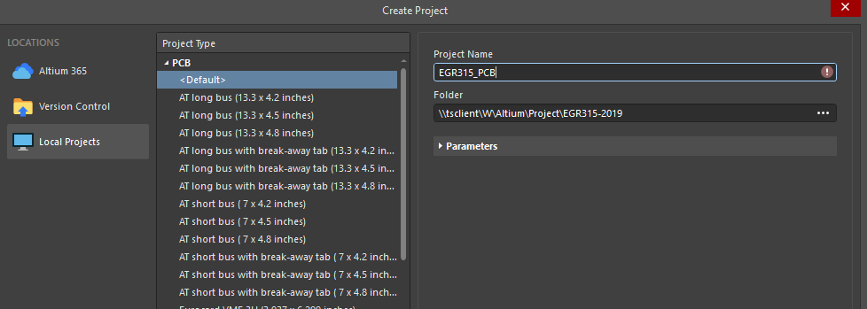

**Figure 4: New project information**

1. If you have done everything correct up to this point, you will see your new project listed on the Project window. Right-click on your new project in the Project window, then select **Add New to Project > Schematic.**  You will notice that a blank schematic loads once you do this.

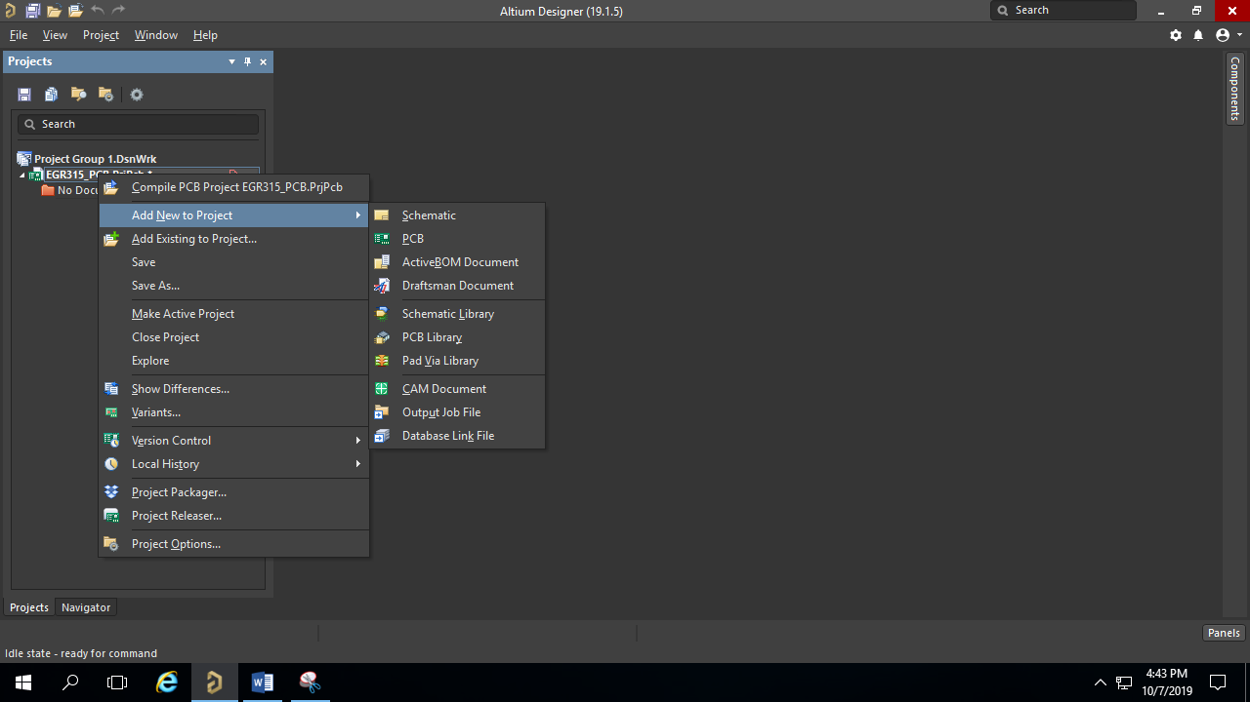

**Figure 5: Opening a new schematic**

1. While holding down the Control key, press ‘S’ (CTRL+S) to save your schematic. This will bring up a Save As window since you have not saved the schematic yet. Name the schematic **EGR315**.
2. Right-click on your new project in the Project window again, then select **Add New to Project > PCB.**  You will notice that a blank PCB loads once you do this. At this point, you should have both the schematic and PCB file visible in the Project window.

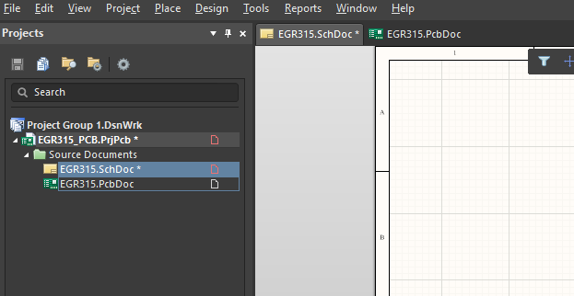

**Figure 6: Schematic and PCB visible in Project window**

1. While holding down the Control key, press ‘S’ (CTRL+S) to save your PCB. This will bring up a Save As window since you have not saved the PCB yet. Name the PCB **EGR315**.
2. Now that both the schematic and PCB have been added to the project, save the project by selecting **File > Save All** to save the project and the individual files. Make sure to save all of your documents often during a design.
3. Now we can begin to design the schematic drawing. Make sure that the schematic drawing is the active drawing and select the Place Part tool.



**Figure 7: Place part tool**

1. When you press the Place Part tool, you will see a window appear on the right-hand side of the screen like in Figure 8. This is where you search for parts to place on the schematic.

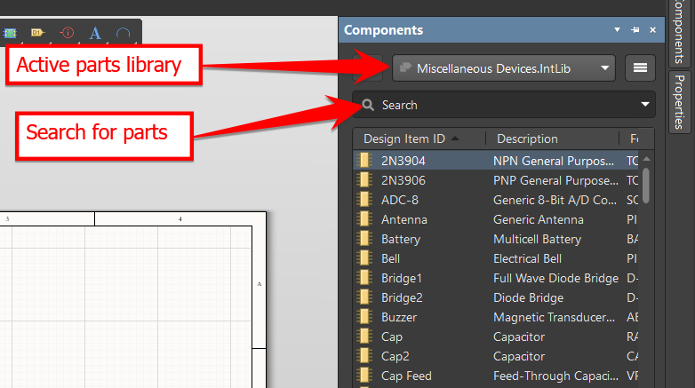

**Figure 8: Place part window**

1. Make sure that **Miscellaneous Devices** is the active parts library and then type **QNPN** into the search box. Press Enter. You will see that there is an available part with that name. Double click the part and move your mouse over to the schematic. You should see a transistor symbol under your mouse pointer. Left click on the schematic to place the part.
2. Repeat step 12 for the parts in the table below.

**Table 1: Schematic parts**

|  |  |  |  |
| --- | --- | --- | --- |
| **Type in search box** | **Description** | **Quantity** | **Symbol** |
| QNPN | Surface mount transistor | 2 |  |
| Res3 | Surface mount resistor | 4 |  |
| LED2 | Surface mount LED | 2 |  |
| Cap Pol3 | Surface mount capacitor | 2 |  |

1. After you have finished adding all of the parts, add a VCC and GND symbol to the schematic.

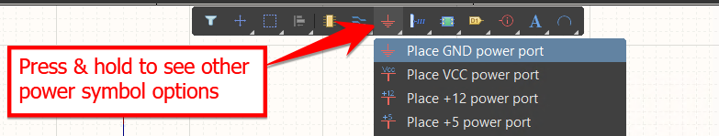

**Figure 9: Placing power symbols**

1. Arrange the parts similar to Figure 10.

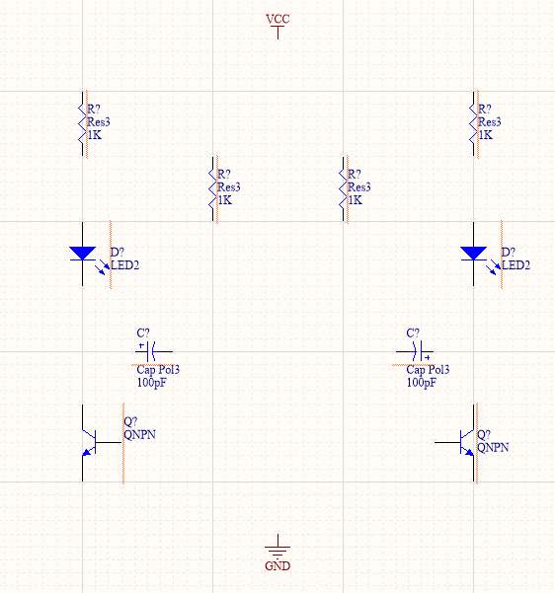

**Figure 10: Arranging parts**

1. Connect the parts using the wire tool. When you are finished, your schematic should look like the schematic in Figure 12.

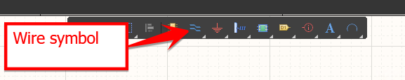

**Figure 11: Adding wires to the schematic**

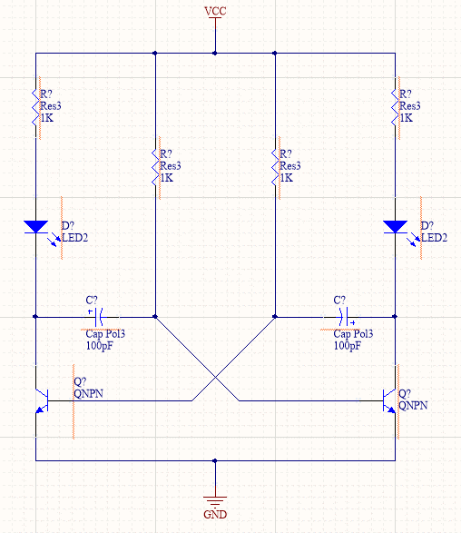

**Figure 12: Schematic with wires**

### Select Tools > Annotation > Force Annotate All Schematics to add designators to your schematic symbols. Now you should see new labels on your parts: C1, C2, R1, R2, R3, R4, D1, D2, Q1, and Q2.

### 

**Figure 13: Annotating a schematic**

1. Select the Place Part tool again.
2. In the component window, change the part library to the **Miscellaneous Connectors** library. Search for **Socket** and add two sockets to the schematic.

### 

**Figure 14: Adding a connector**

1. Add another VCC and GND symbol to the schematic and connect them as shown in Figure 15.

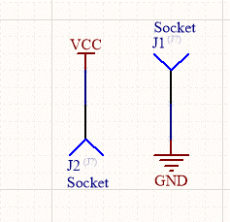

**Figure 15: Power connectors**

### Force annotate your schematic once again to get the designators for the sockets.

### Your completed schematic should look like Figure 16 below.

### 

**Figure 16: Completed schematic**

1. The last thing to do before starting the board layout is to compile the PCB project. Right-click on the **EGR315_PCB.PrjPcb** file in the Projects window. Select “**Validate” EGR315_PCB.PrjPcb** from the list to compile. If you have made any errors, they would pop up here like in the **Compile Design** video from the prelab. If you have no errors, move on to the PCB layout. If you have errors, make sure to correct the before moving on.

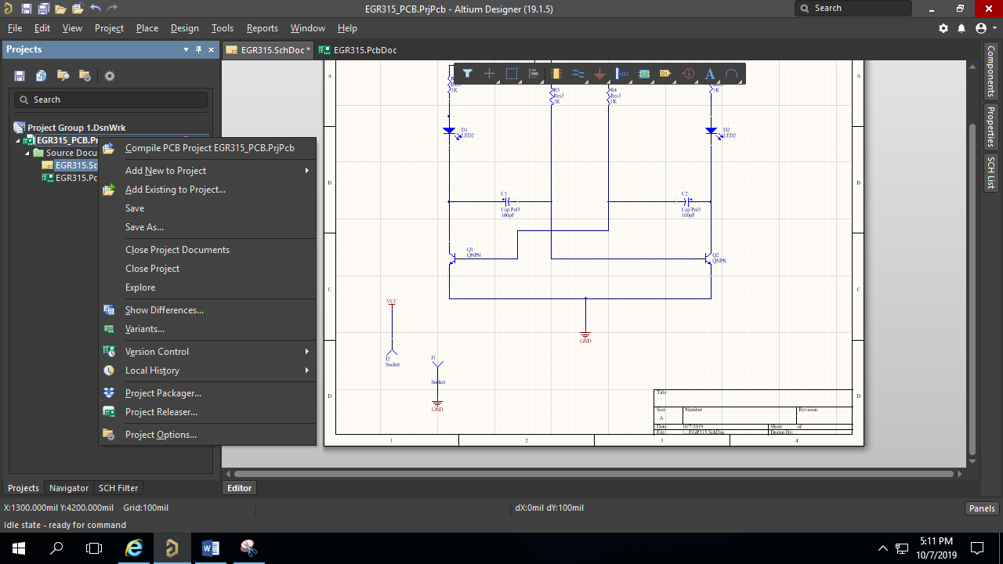

**Figure 17: Compiling the schematic**

### Part II – Board Layout

1. Now that you have the schematic drawn, it is time to lay out the board. To start the board layout, open the **EGR315.PcbDoc** file. If your board file is not already open, you can open it from the Projects window as shown below.

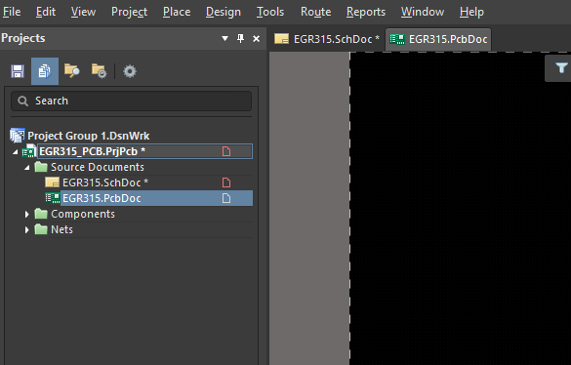

**Figure 18: Opening the board file**

1. Change the origin of the PCB to the bottom left corner of the PCB. This is also explained in the **Transfer 2 PCB** video.

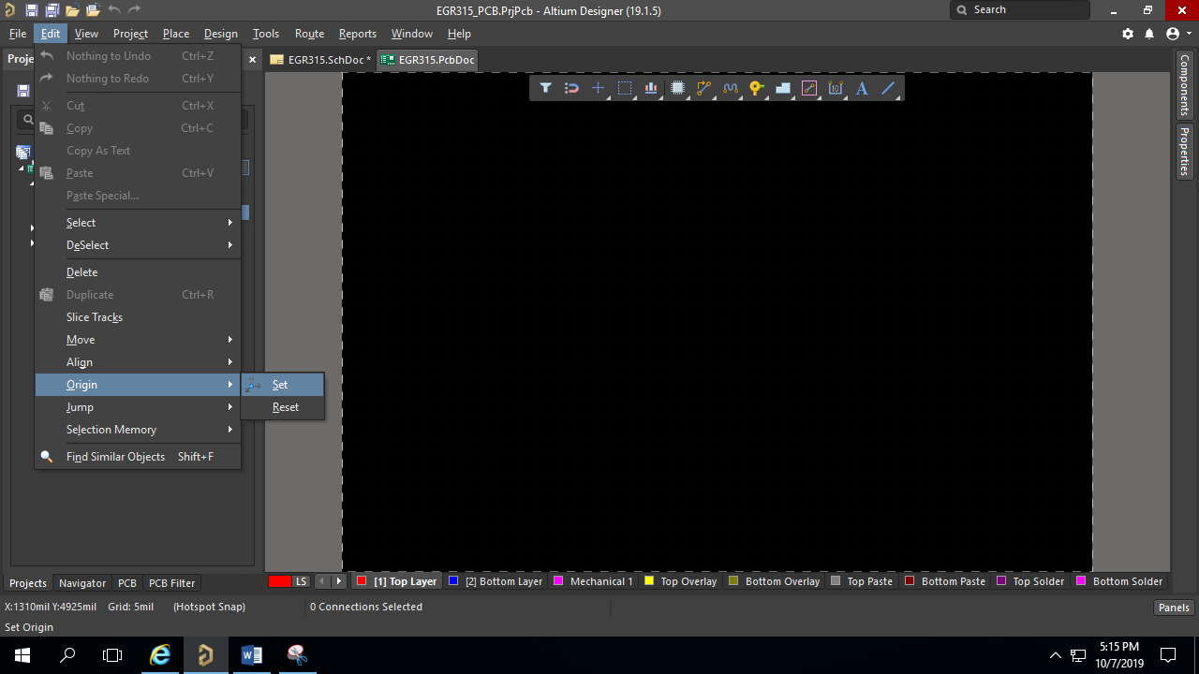

**Figure 19: Setting the origin**

1. Press 1 on your keyboard to enter board planning mode. Your PCB should turn a green color.
2. In board planning mode, select **Design > Edit Board Shape** from the menu.

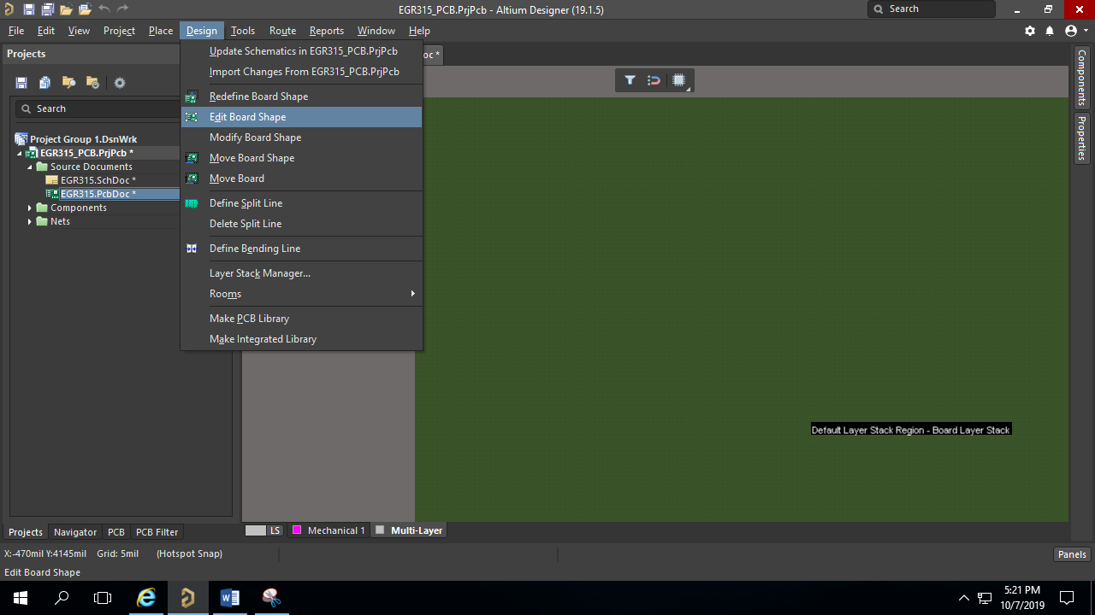

**Figure 20: Editing the PCB shape**

1. Resize the PCB to 3 inches by 3 inches.

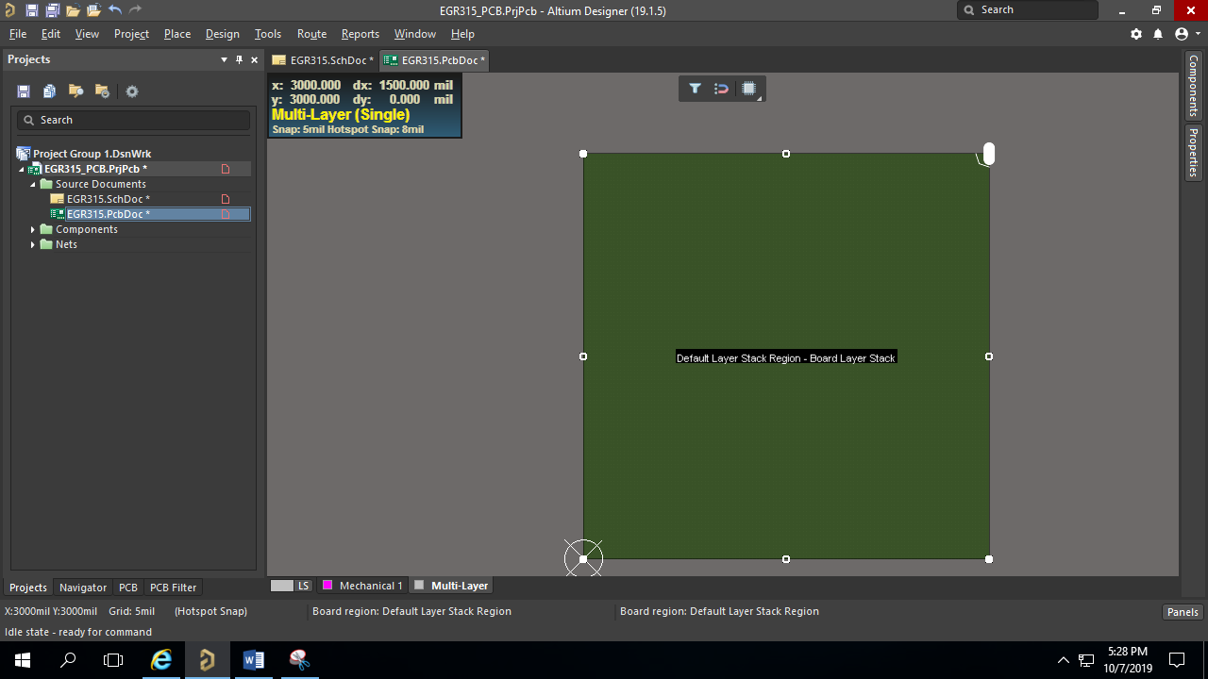

**Figure 21: Resizing the PCB**

1. Press 2 on your keyboard to exit board planning mode and change back to design mode.
2. Go back to the schematic drawing and select **Design > Update PCB Document** to add the schematic components to the PCB document. Select **Validate Changes** and then select **Execute Changes** on the Engineering Change Order screen.

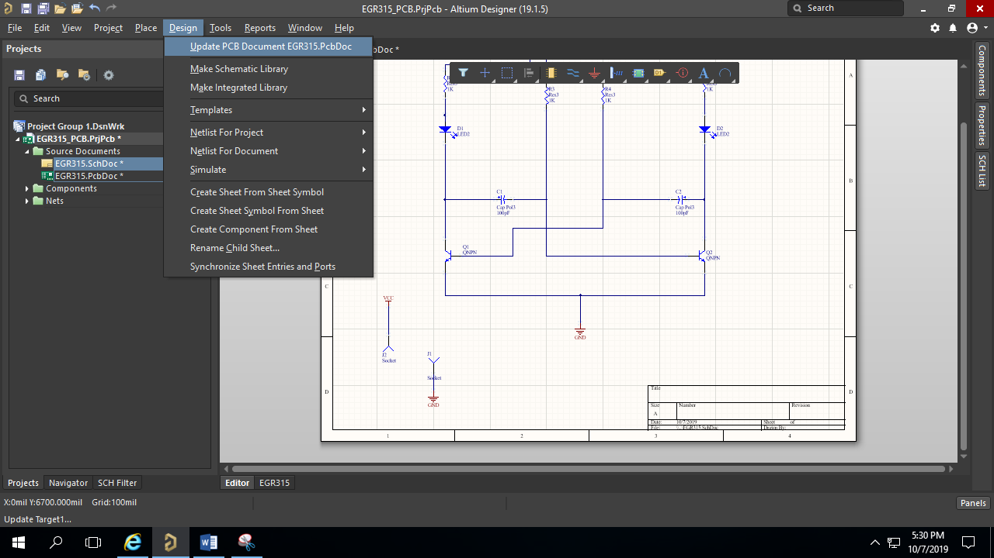

**Figure 22: Adding components to the PCB document**

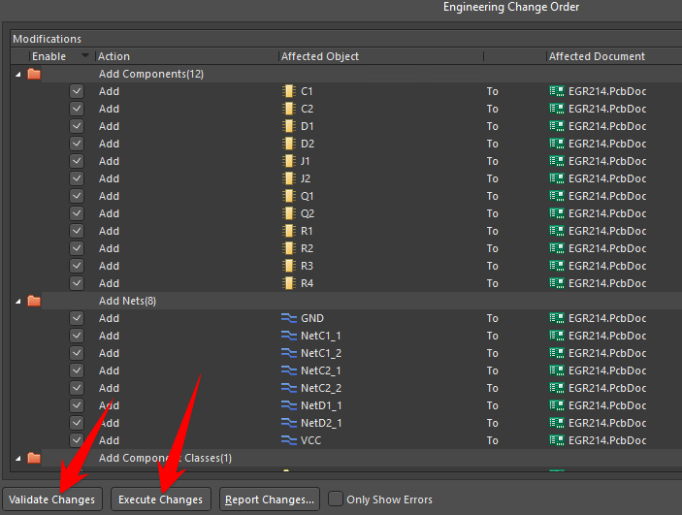

**Figure 23: Engineering change order screen**

1. You should now see components on your PCB document like shown in Figure 24.

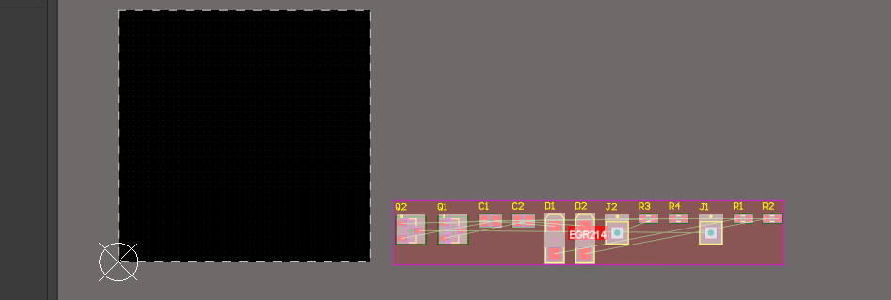

**Figure 24: PCB with components**

1. One-by-one, drag the components onto the PCB and place them similar to Figure 25.

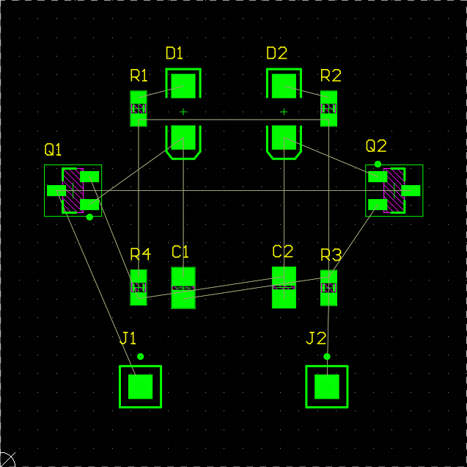

**Figure 25: PCB component arrangement**

1. Now it is time to route the PCB traces. Use the Interactive Route tool to add traces to the PCB. Route all of the traces except for the **GND** traces. We will connect those with a polygon later on.

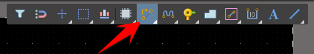

**Figure 26: Routing PCB traces**

1. You will notice that it may be difficult to route all of the traces onto the same side of the PCB. Add a **via** to your trace to bring the trace to the other side of the PCB. Watch the video on routing if you do not remember how to add a via. Remember, the via has to be on the same net as the trace to make a connection.

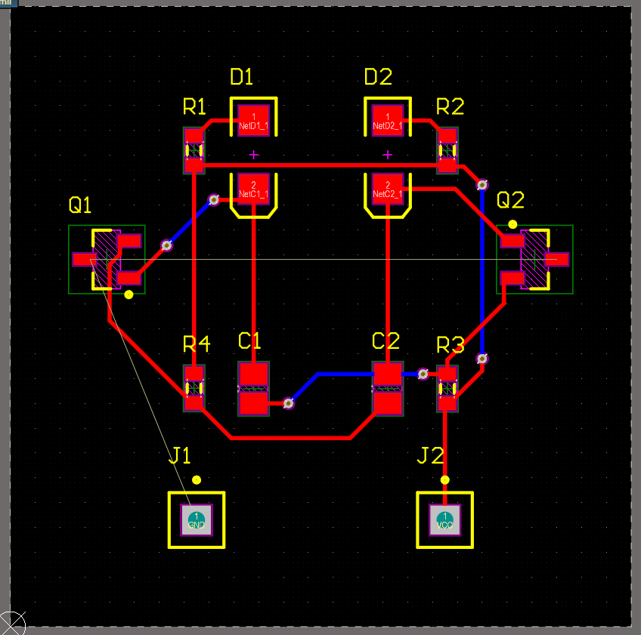

**Figure 27: 2-layer PCB ready for a ground plane**

1. Now we need to add a ground plane to the PCB. Select **Place > Polygon Pour** and draw the polygon on top of the PCB. Make sure to cover the PCB completely. Press ESC twice to exit the polygon tool. Your PCB will turn red if you successfully added the plane.

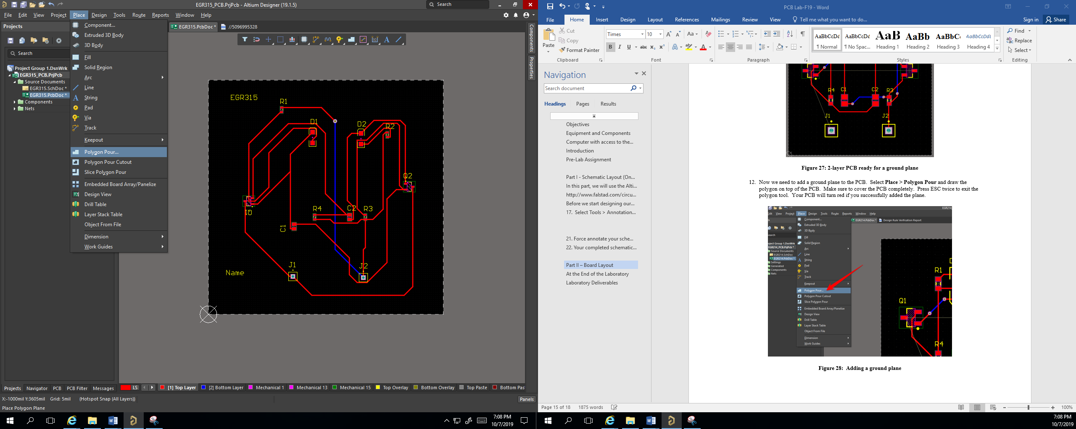

**Figure 28: Adding a ground plane**

1. Now, change the net of the polygon to **GND** by double-clicking on the polygon and selecting GND for the net in the Properties window.

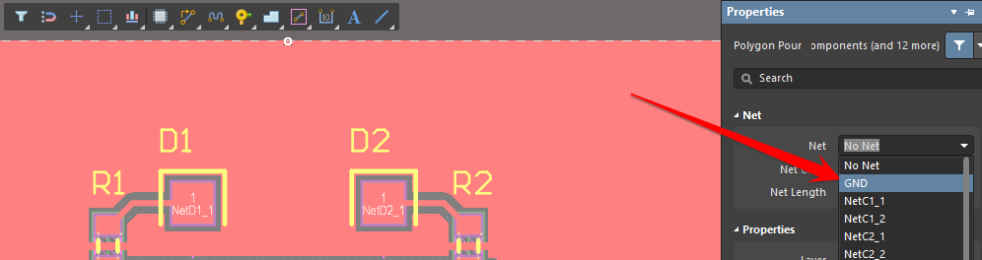

**Figure 29: Changing the ground plane net**

1. You will notice that everything will turn green after you change the net to GND. These are all errors. To get rid of the errors, select **Tools > Polygon Pours > Repour All**.

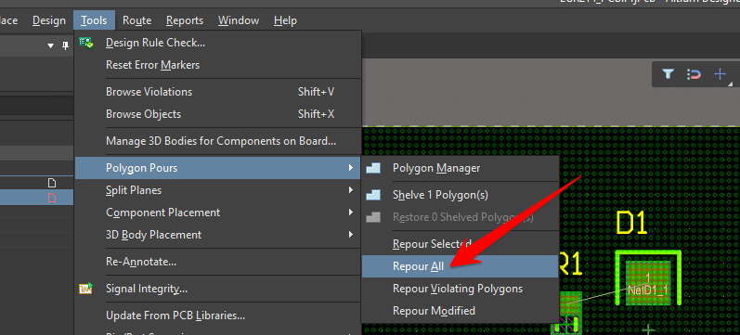

**Figure 30: Polygon repour**

1. You will notice that the polygon errors disappeared, but not the component errors. This is because we have the room rule enabled. That pink box next to your PCB is the room for the components. On a board this small, you can just ignore this rule by turning the rule off. On the other hand, if the errors do not bother you, do nothing.

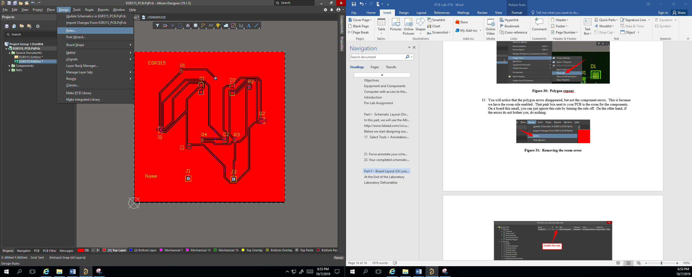

**Figure 31: Removing the room error**

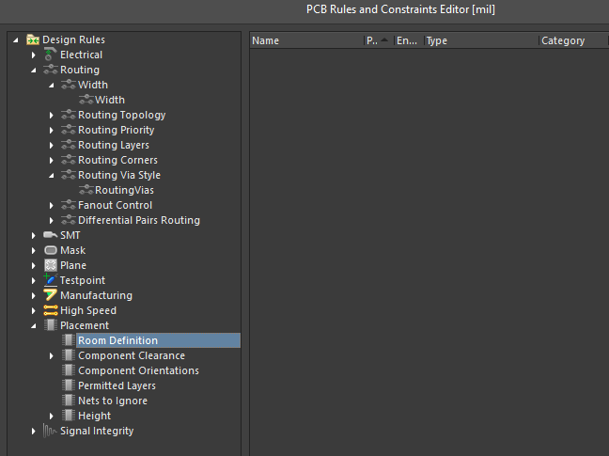

**Figure 32: Removing the room error**

1. Now we will add the final touches to the PCB. We want to add two lines of text to the PCBs silkscreen. Make sure that your active layer is the top overlay layer.

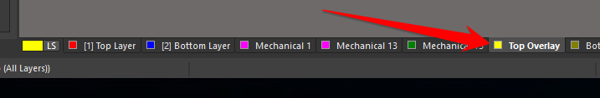

**Figure 33: Changing layers**

1. Select **Place > String** to place text on your PCB. Add a title at the top of the PCB and your name at the bottom.

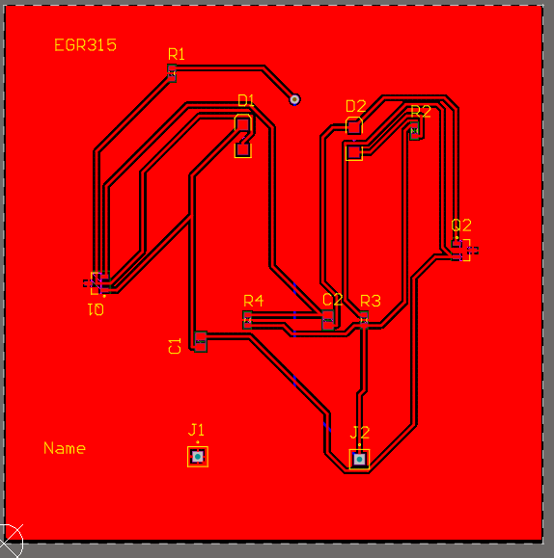

**Figure 34: Final PCB**

1. Press the number 3 on your keyboard to enter the 3D layout mode. This is a 3D model of your finished PCB.

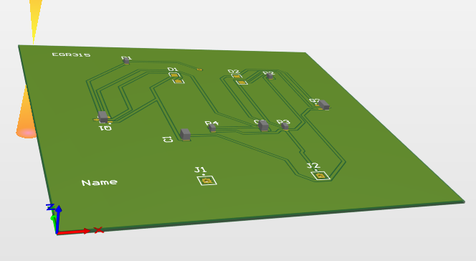

### Part III – Design Your Own

There are two libraries you have access to.

Miscellaneous Devices.IntLib

Miscellaneous Connectors.IntLib

In the Devices Library, you will need the following parts:

MOSFET-N (package = E3) (Can also be used for the hall effect sensor)

RES-3 (Thru-hole ¼ watt resistor)

LED-1 (Thru hole LED)

In the Connectors Library, you will need the following parts:

Search for keyword “header”.

This will give you many options for header pins to solder (or direct wire soldering)

You may also use individual “sockets” as described in the above example.

DESIGN:

Create a circuit that will interface with:

* RTC (with pullup resistors)
* 2-6 level shifting circuits
* Hall effect sensor (with pullup)
* 5V, 3.3V and ground
* Extra headers to connect to the MSP
* Any other circuitry you would like to include (to simplify your wiring!)

PCB:

* Board must be no larger than 10 cm x 10 cm
* Board must be double sided

### Laboratory Deliverables

Include a screenshot of your completed schematic and PCB design in your lab notebook.